Software Requirements Specification
for
Online Taking Care Service for Children and Elderly people
Version 1.0 approved
Prepared by
1.Shanjida Islam Labonno (ID:20-42958-1)
2.Md. Tahmid Ashraf Chowdhury (ID:20-43001-1)
3.Md. Ashraful Amin Sakib (ID:20-42940-1)
4.Md. Nafis Ulfat (ID: 20-42248-1)
5.Nusrat Jahan Maria (ID: 20-42516-1)
American International University-Bangladesh
12-12-22
Table of Contents
1. Introduction 1
1.1 Purpose 1
1.2 Document Conventions 1
1.3 Intended Audience and Reading Suggestions 1
1.4 Product Scope 1
1.5 References 2
1.6 Definitions, acronyms and abbreviations 2
2.Overall Description 3
2.1 Product Perspective 3
2.2 Product Functions 3
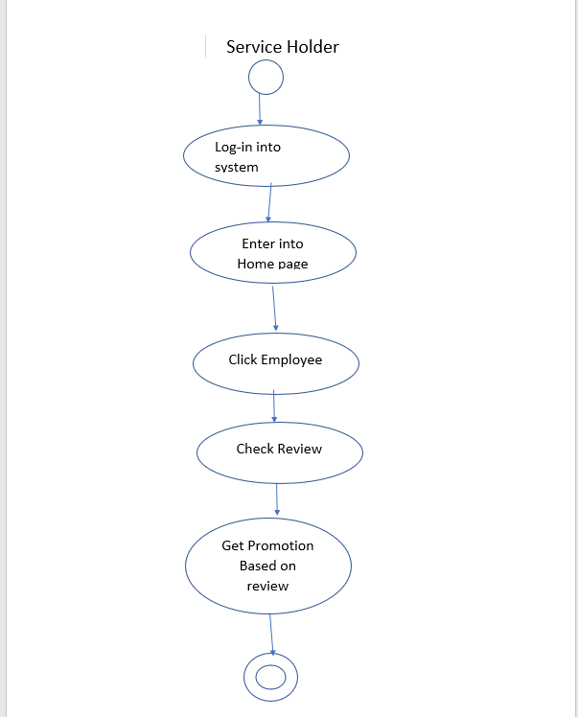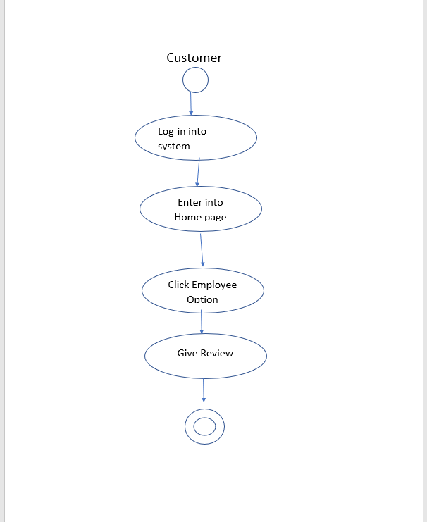 4
2.3 User Classes and Characteristics 5
2.4 Operating Environment 6
2.5 Design and Implementation Constraints 6
2.6 User Documentation 7
2.7 Assumptions and Dependencies 7
3.External Interface Requirements 7
3.1 User Interfaces 7
3.2 Hardware Interfaces 9
3.3 Software Interfaces 9
3.4 Communication Interfaces 9
4.System Features: 9
4.1 . Registration 11
4.1.1. Description and priority 11
4.1.2. Stimulus or Response sequencee 11
4.2 . Payment 11
4.2.1. Description and priority 11
4.2.2. Stimulus for payment: 11
4.3. Tracking 11
4.3.1. Description and priority. 11
4.4. Report 12
4.4.1. Description and priority 12
4.4.2. Stimulus for report 12
5. Other Nonfunctional Requirements 12
5.1 Performance Requirements 12
5.2 Safety Requirements 13
5.3 Security Requirements 13
5.4 Software Quality Attributes 13
5.5 Business Rules 14
6. Other Requirements 14

Introduction

Purpose
The software described in this document is currently called Online taking care service for children and elderly people and is hereafter referred to as the OTCS. This name might change later. The first release of the OTCS is projected to have the version number 1.0. This document is to describe its functionality.

Document Conventions
We have used font 12 of Times new roman in order to ensure the document is easy to read and follow. We have provided a table of contents, titles and headlines in this document. Along with this we also use bold letters to highlight the important parts of the document. We have also included images and diagrams.

Intended Audience and Reading Suggestions
This project is a prototype for the Online taking care service for children and elderly people system. This has been implemented under the guidance of caring services. This project is useful for the older people and children, by using this system all family member will be stress free.
Here is a list of collaborators to this document. The draft will be sent to this email list for feedbacks
and comments.
Shakil | Shakil19@gmail.com
Riad | Riadal12@yahoo.com
Akram Khan | ak@outlook.com
Sakib | maasakib@yahoo.com
Tahmid | taha@gmail.com
Nafis | nafisfuad@gmail.com
Labonno | labonno@gmail.com
Nora | nora@yahoo.com

Product Scope
This is the Online taking care service for children and elderly people by using this system their family member will stress free about their caring. Before go out from home they can check service provider location by using tracking service. Using this tracking system user ensure service provider is arriving there. Customer and Service provider have unique profile and also ID. It is a website selecting service, easily can be find out from searching in browser. Payment method also provide will be there. Customer can be payment by using card, mobile banking. All data is maintained in database and in log files.
It’s about a wide range of services such as getting assistant, adult daycare, nursing care, home care, baby care and long-term care. We provide specialized elderly and baby care in Bangladesh to the citizens in various stages. Our preliminary development plan is to focus on improvements first, as these will be immediately valuable to users, while simultaneously giving us a means to get acquainted with the project environment. We will then gradually transition to prioritized feature development.

References
These are the references we have followed throughout the SRS projec.

1. https://www.altexsoft.com/blog/business/functional-and-non-functional-requirements-specification-and-types/
2. https://krazytech.com/projects/sample-software-requirements-specificationsrs-report-airline-database
3. https://nammco.no/wp-content/uploads/2018/05/o04-software-requirements-draft-specification-for-supersurveyor-programme.pdf

Definitions, acronyms and abbreviations
Term | Definition
User | A person who is guardian of elder or children
Tester | A person testing the functionality of the system
Developer | A person constructing the system or web application
Administrator | A person managing the web application
Google Map | Tracking service provider location
Database | Collection of all the information monitored by this system
Web portal | A web application which stores and shows data
The cloud | Web portal
Observer | Person reporting sightings
Payment | User pay their service charge by mobile banking or card.

2.Overall Description

Product Perspective
People will have to deal with the issue of old age and child care now and in the future, which must be addressed immediately. The problem will be solved to a large extent by developing this software system. Students can spend their free time here, gain experience, and earn money.

Working parents can hire service providers to look after their children if they are under 5 years of age.
Both the service provider and the customer have to register in the system. They will have specific profiles and the location will be identified or verified by the map.

The service provider's rank and resume in the system will be updated based on customer satisfaction. Moreover, customers will get offers based on system usage.
If immediate service is required, customer can avail the service by calling customer care.

Nursing services are provided to older people with children who require skilled nursing care and rehabilitation. Although the majority of facilities serve the elderly, some facilities also serve younger people with special needs, such as the developmentally disabled and the mentally ill. Nursing provides specialized services such as therapies, pharmacy services, and specialty care.

Product Functions
As a Service provider can login system, enter into home page, confirm employees request, see reviews about him and get review-based promotion. On the other hand, the customer can login to the system, visit the homepage and also choose the service of his choice from the employee options. Customer ca give review based on the work of the service provider.

2.3 User Classes and Characteristics
The system will support three types of user Customer, Service provider and Employee. Customers will have access to customer functions, Service provider will have access to service provider functions and the employees will have access to both customer and management functions.

The customer should have been able to do the following Function:

- Create account.
- Login System.
- Update Profile.
- Search service.
- Enable Location.
- Request for Service.
- Payment.
- Give Rating.
- View Service provider details.
- Logout system.
- View Notice.

The Service provider should have been able to do the following Function:

- Create account.
- Add resume.
- Update Profile.
- Enable Location.
- Confirm Service.
- Logout System.
- View notice.

The Office employee should have been able to do the following Function:

- Give Notice.
- View service provider and customer location.
- Update Software.
- Maintain software.
- Block most reported account.
- Add a new account.
- Obtain system errors.
- Customer care service.

Operating Environment
- Online taking care service for children and elderly people web interface shall operate with the following Web browsers: Microsoft Internet Explorer version 6.0 and Mozilla Firefox version 3.0.
- Online taking care service for children and elderly people web server is MySQL versions 5.0 or above.
- distributed database.
- client/server system.
- platform: vb.net/Java/PHP.

Design and Implementation Constraints
- UML 2.0 shall be used for the system’s analysis and design.

- ASP.NET shall be used as the programming language to be compatible to the provided devices’ interfaces.

- In this first release, for the simplicity, web interface shall be simulated by a window application interface.

User Documentation

- The system shall provide an online hierarchical and cross-linked help system in HTML that describes and illustrates all system functions.

- The system shall provide an offline help system in CHM that describes and illustrates all system functions.

- The project shall provide a soft-copy of user manual for the home owners who enrol the system.

Assumptions and Dependencies
Let us assume that this is an Online taking care service for children and elderly people and it is used in the following application:

- Helping daily elderly people and ensuring their safety.
- Understand their need and situation.
- A request for booking/cancellation of a service from any destination, giving connected control by office employee.

3.External Interface Requirements

3.1 User Interfaces
Each part of the user interface intends to be as user friendly as possible. The button and fonts used will be intended to be very fast and easy to load on web pages. The pages will be kept light in space so that it won’t take a long time for the page to load.
The starting page will be the home page of the services. All the services including employee’s information are displayed. An ‘Add to Cart’ button is available through which a customer can ensure to take the service by pressed that button only if the user logged into his/her account.
And also, the employee can see the customer requested service. A ‘Requested or Accept button’ is available through which a service provider can ensure the customer
A logged in user can also view the service they provided or taken. There are pages which displays the details accordingly.
These are some examples of User interfaces in our system.
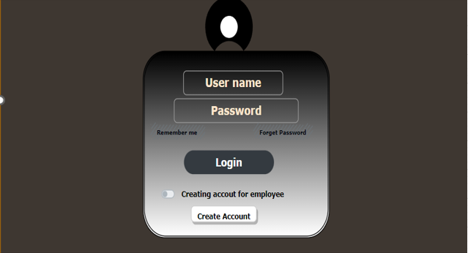

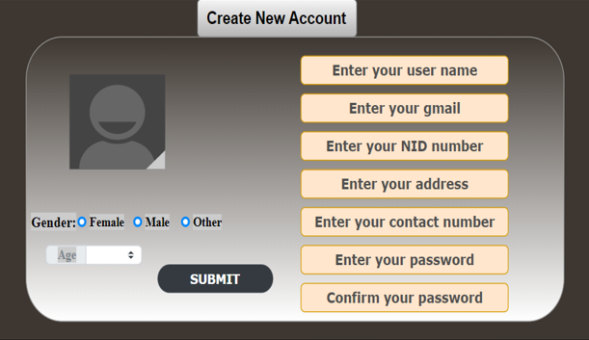
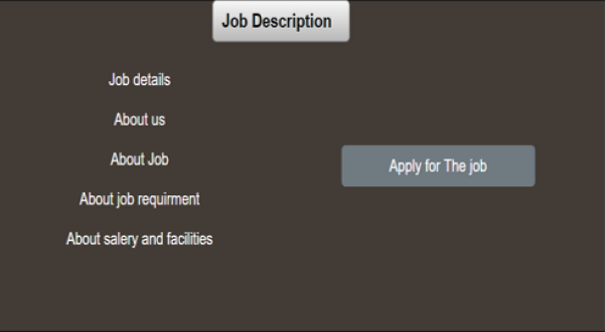

3.2 Hardware Interfaces
- Electronic device which supports cellular network
- GPS
- Photo of the service provider.
- A browser which supports CGI, HTML & JavaScript.

3.3 Software Interfaces
- Operating System: Unix, Linux, Mac, Windows etc.
- Application: XAMPP application
- Development tool: PHP, JavaScript, Ajax
- Database: MySQL database server
- Cloud interface

3.4 Communication Interfaces
PHP uses session variables to communicate between pages of the website. E-mail/phone number/NID no will be associated with personal communication. Communication standards will be TLS based. We will use electronic form to get feedback and data from the user.

4.System Features:
Features are the ‘tools’ used within a system to complete a set of tasks or actions. Functionality is how our features actually work to provide with a desired outcome.
In our software given the best quality advantages and user friendly.
- Registration
- Login
- Notify or alert
- Time
- Payment
- Tracking
- View Data
- Backup
- Favourite persons list
- Report
- Benefits
- Cost
- Risk
- Penalty
- Rating

High priority:
Alert, tracking, report, rating, security, payment and time
Medium priority
Registration, login, benefit, view data, backup
Low priority
Cost, risk, penalty

Registration: Software required documents with the Securities and Exchange Commission (SEC), detailing the particulars of a proposed public offeringg.

Login: Login by your won Id and password with security sanding code in phone number or mail.

Notify or alert: If anyone want to or trying to enter your account with wrong password in 5 time, your installation software will be notifying you. And in others, you will also notify you by given mail or phone number.

Time: It will clarify a customer how much time they’ll be hired a nanny for their baby or elders one with given the prices.

Payment: After selecting a nanny, for confirmation request customer must be payment half of deal on online in ROKET, BKASH, NOGOD.

Tracking: If the nanny faces any difficulties to holding the work time or how the nanny will be given the service of the house, for satisfaction customer can keep an eye on them.

View data: Customer can check their won details through this feature how many times they taken this service.

Backup: Customer and admin can save their personal details by this feature.

Favourite person list: Customer can mark a nanny for taken the best service and they can hire them again for the service.

Report: If any nanny tries to misbehave with the customer or children or if they can’t give full of opportunity that are declared. Customer can complain through this feature. By this feature we try to make the more careful and give the more batter service.

Benefit: It will be saved time, money and less pain.

Cost: No any cost to using this software.

Risk: No any risk to using this software with fully secured.

Rating: Rating must pay after taking the service from this software which is encouraging us to given it more batter and quality service.

. Registration

4.1.1. Description and priority: Software required documents with the Securities and Exchange Commission (SEC), detailing the particulars of a proposed public offering which is a medium priority system feature.

4.1.2. Stimulus or Response sequence: According to use case diagram in our software given the easiest was to use. First of all, it shows some guid line and rules regulations to use. After that, there customer has one button to go to Registration or another button Cancel. Click on this registration button where dashboard will be appeared in front of the customers. Some personal information must be needed for using it and for confirmation OTP will be sand on customer’s phone number or mail. After that an account will be ready for use. Then, it will login option which has on the left side Back button another one is next and middle one tries again (5 times), it will be sand for alert OTP mail or phone number. And it will be blocked go few minutes. Under this dashboard one option will showing “Forgot password “. By this option Forget password user can change with security. Clicking Next option user can see three buttons like
4.1.3. Functional Requirements:
- ﻿﻿REQ-1: The system should enable users to complete and submit forms.
- ﻿﻿REQ-2: The program should get information from the database.

. Payment

4.2.1. Description and priority: After selecting a nanny, for confirmation request customer must be payment half of deal on online in ROKET, BKASH, NOGOD. Payment is high priority feature

4.2.2. Stimulus for payment: User must have an online payment account may on BKASH, ROCKET or NAGAT. If user have on any accounts or idea how to open an account online. Our features also help to open it. For that user must have submit photo and national ID card. And secret pin code with phone number. After that, on their online payment account must have enough money to half payment of nanny when complete their confirmation.
4.2.3. Functional Requirements:
- ﻿﻿REQ-1: The system should enable users to complete and submit forms.
- ﻿﻿REQ-2: The program should get information from the database.

4.3. Tracking

4.3.1. Description and priority: If the nanny face any difficulties to holding the work time or how the nanny will be given the service of the house, for satisfaction customer can keep an eye on them. Tracking is a high priority feature.
4.3.2. Stimulus for tracking: User must have tracking software which is required from our Software system. Without that tacking system user can’t tacking nanny when they are on work. Another important one is that, user must have CC camera in their house so that they can focused on them properly. For this feature or software can use from our description link.
4.3.3. Functional Requirements:
- ﻿﻿REQ-1: The system should enable users to complete and submit forms.
- ﻿﻿REQ-2: The program should get information from the database.

Report

4.4.1. Description and priority: If any nanny try to misbehave with the customer or children or if they can’t give full of opportunity that are declared. Customer can complain through this feature. y this feature we try to make the more careful and give the more batter service. Report is a high priority feature.

4.4.2. Stimulus for report: User can complain about our nannie’s bad behaviour or other things, but it must be meaningful reasons. Without that if any user tries to insult any nannies without any proof, for that user our software system can’t give any services again. And proof must be required and meaningful.
4.4.3. Functional Requirements:
- ﻿﻿REQ-1: The system should enable users to complete and submit forms.
- ﻿﻿REQ-2: The program should get information from the database.

5. Other Nonfunctional Requirements

5.1 Performance Requirements
Performance requirements under various circumstances are given below. Performance requirements for software can include:
• Speed—the ability to complete tasks quickly and efficiently.
• Memory and processing power—the system should be able to handle large amounts of data and process them in a timely manner.
• User interface and experience—an intuitive and user-friendly interface is crucial for a good overall experience.
• Quality of content—high-quality visuals, audio, etc. should be provided.
• Scalability—being able to increase the features and capabilities of the software over time.

5.2 Safety Requirements
Safety requirements for software can include the ability to protect user data, prevent malicious attacks, adhere to industry standards and regulations, provide user privacy and control, maintain secure authentication systems, and regularly audit the system for security issues. Safety requirements for software can include:
- Authentication of users – Passwords and other methods of account security should be implemented.
- Secure data storage – Use of encryption techniques to protect user data.
- Error handling – The system should be able to detect and address errors as they occur.
- Access control – User access should be restricted to authorized individuals only.
- Security testing – To identify potential vulnerabilities in the system.
- Malware protection – The system should be able to detect and remove malicious software.
- Network security – The system should be able to protect against external threats.
- System updates – Regular software updates should be done to ensure.

5.3 Security Requirements
Security requirements for software can include authentication of users, secure data storage, error handling, access control, security testing, malware protection, network security, and regular system updates to ensure the system remains secure. Security requirements for software can include:
- User authentication to control access to the software.
- Secure data storage to protect confidential information.
- Encryption of data in transit and at rest.
- Regular software updates to patch any gaps or vulnerabilities.
- Separation of privileges to keep users from having too much access.
- Intrusion detection systems to detect any suspicious activity.
- Secure network perimeter to prevent unauthorized access.
- Secure coding practices to ensure a secure coding environment.
- Security testing to ensure that all aspects of the software are secure.

5.4 Software Quality Attributes
Software quality attributes can include functionality, usability, reliability, maintainability, security, performance, scalability, interoperability, and supportability. These criteria measure the overall quality of the software - how well it meets user needs, is easy to use, performs as expected in different environments, and is up-to-date with the latest technologies. Software quality attributes can include:
- Functionality – The software should be able to perform all the tasks intended by its design.
- Usability – The software should be easy to use and understand by its intended users.
- Reliability – The software should be able to run continuously without crashing or data loss.
- Maintainability – The software should be able to easily adapt to modifications and upgrades.
- Security – The software should be secure from outside threats such as viruses, malware, and data breaches.
- Performance – The software should be able to respond quickly and efficiently to user requests.
- Scalability – The software should be able to support increasing.

Business Rules
Business rules for software can include data security, compliance with regulatory standards, user privacy, security audits, maintenance and upgrades, user accessibility, performance monitoring, and cost-effectiveness. These criteria measure how well the software meets the business goals and objectives, ensures a secure environment, adheres to legal and industry regulations, and is cost-effective for the company. Business rules for software can include:
- Data security – The software should be able to protect sensitive customer data from unauthorized access.
- Compliance with regulatory standards – The software should adhere to industry standards such as PCI, HIPAA, and GDPR.
- User privacy – The software should provide users with detailed information about their privacy rights and what data is being collected.
- Security audits – Regular security audits should be done to ensure the software is secure and compliant.
- Maintenance and upgrades – Regular maintenance and updates should be done to ensure the software remains up-to-date.
- User accessibility – The software should be accessible and useable by all users regardless of physical.

Other Requirements
Appendix A: Glossary
None
Appendix B: Analysis Models
None
Appendix C: To Be Determined List
None

